College Scholarship Opportunity
Tonasket Fire Department OCFD #4

Event Timeline
April 1
Deadline for Applications
Email to: TonasketfireScholarship@ gmail.com
May 1
Review of Applications
June 1
Scholarship Awarded!

PO Box 79, Tonasket, WA 98855
TonasketfireScholarship@gmail.com T: 509-486-2611
Attention Graduates of Tonasket High School!
The Tonasket Fire Department congratulates all of you on your final year of high school, and would like to offer some assistance to those continuing their education at any 2 to 4-year college or university.

What are we looking for?
All students applying for college will be considered; however, in particular we seek those pursuing a degree in:
- Forestry
- Fire Science
- Pre-Nursing/Pre-medical
- Emergency Management
Our hope is to invest in the community we serve by aiding those interested in a career contributing to emergency preparedness!
What do you get?
1 Scholarship in the amount of $1000 towards tuition, books, or classroom materials!
How to apply?
By email, submit a copy of your college acceptance letter and your high school transcript. Also, please answer the following questions on a Word document:

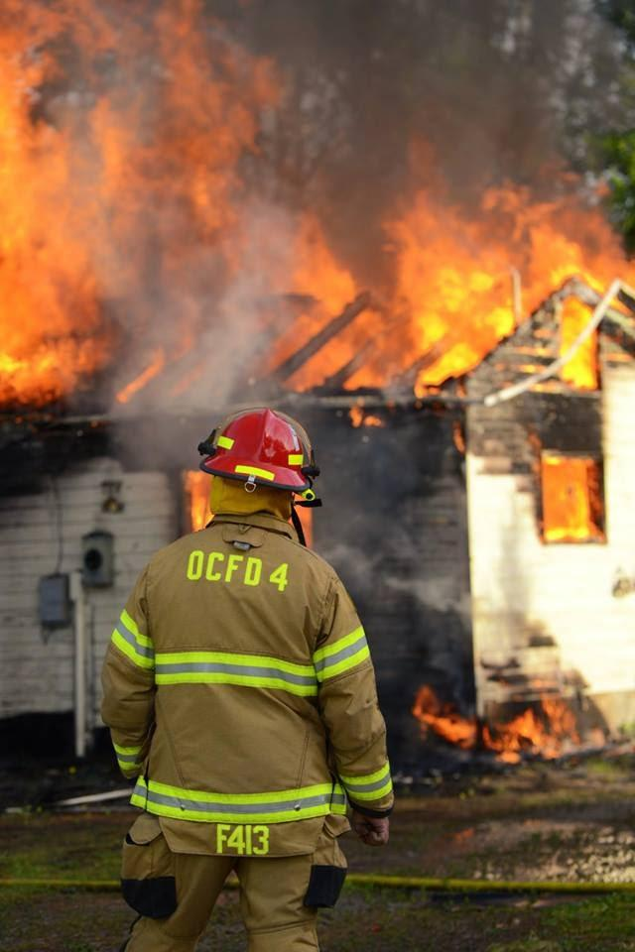
Short-Answer Questions

Are you pursuing a degree/career in one of the above fields? (Forestry, Fire Science, etc.)
Yes No (please list): ______________________

- What made you decide to pursue your chosen degree/career?

- What community service projects or volunteer programs have you participated in?

- Explain how you have prepared for the emergencies that affect our area? (Wildfire, structure fire, vehicle accident etc.)

- Please provide a brief (1-page max) letter of recommendation from 1 teacher and 1 adult member of the community.

